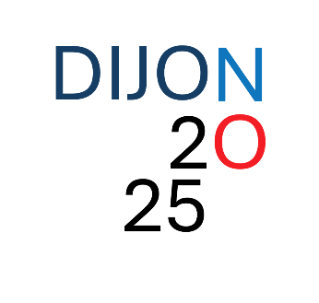**Presentation Guidelines**

**Poster presentations**

* **Poster dimensions**: A0 size in portrait orientation.
* **Poster flash talks (optional)**: The poster flash talks are meant to be **very brief** (1-2 minutes maximum, using only 1 slide). Focus on delivering your key message to encourage attendees to visit your poster during the breaks.

**Short talks**

* Short talks will be selected from submitted abstracts, depending on the number of participants.

**For both poster and short talks presentations, please follow the abstract template provided below (in Word format) and submit it to:**

[meeting-organizers-dijon@u-bourgogne.fr](mailto:meeting-organizers-dijon@u-bourgogne.fr)

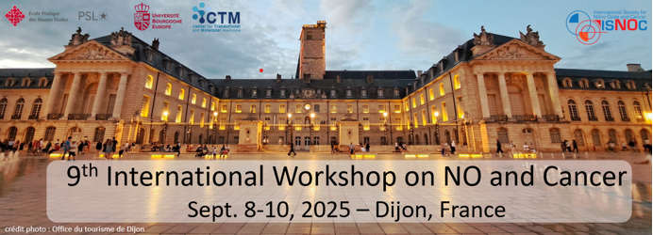**Title**

**Authors** (underlined the presenter)

**Affiliations**

**Abstract** (max 500 words)

**Key words** (3-5)

**Preferred conference type:**

* **Poster**
* **Poster + flash oral presentation**
* **Short talk**